Practical No. 14
Aim : 2) Design an applet/application to create form using Text Field, Text Area, Button and Label.

Name : Danish Altaf Solkar | Class : CO - B
Enrolment no. : 24111590805 | Batch : 2

Code :-
import java.awt.*;
public class login {
login() {
Frame f = new Frame("Login Page");
f.setSize(1000, 1000);
f.setVisible(true);
f.setLayout(new FlowLayout());
Label l1 = new Label("Username");
Label l2 = new Label("Password");
TextField t1 = new TextField("Enter your Username", 20);
TextField t2 = new TextField("Enter your password", 20);
Button btn = new Button("Submit");
f.add(l1);
f.add(t1);
f.add(l2);
f.add(t2);
f.add(btn);
}
public static void main(String args[]) {
login obj = new login();
}
}

OUTPUT :-
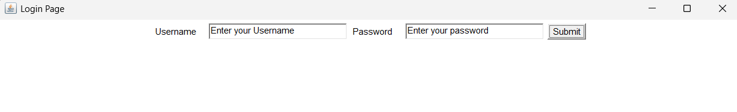

Aim : 3) Write a program to create three Buttons with Caption OK RESET and
CANCEL.

Code :-
import java.awt.Button;
import java.awt.*;
class button {
button() {
Frame f = new Frame("question 2");
f.setSize(500, 500);
f.setVisible(true);
f.setLayout(new FlowLayout());
Button b = new Button("OK");
Button b2 = new Button("RESET");
Button b3 = new Button("CANCEL");
f.add(b);
f.add(b2);
f.add(b3);
}
public static void main(String args[]) {
button a = new button();
}
}

OUTPUT :-
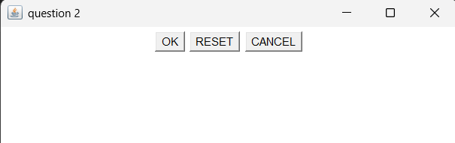

Aim : 4) Develop an applet/application using List components to add names of 10 different cities.

Code :-
import java.awt.Button;
import java.awt.*;
class button {
button() {
Frame f = new Frame("question 2");
f.setSize(500, 500);
f.setVisible(true);
f.setLayout(new FlowLayout());
Button b = new Button("OK");
Button b2 = new Button("RESET");
Button b3 = new Button("CANCEL");
f.add(b);
f.add(b2);
f.add(b3);
}
public static void main(String args[]) {
button a = new button();
}
}

OUTPUT :-
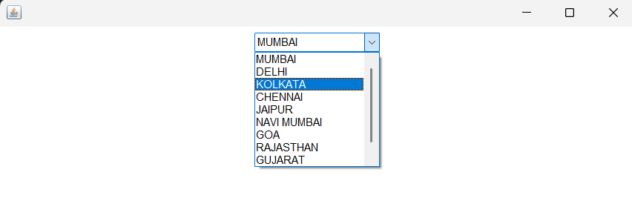

Aim : 5) Develop applet/application to select multiple names of newspapers.

Code :-
import java.awt.*;
public class prac14 extends Frame {
prac14() {
setSize(500, 500);
setVisible(true);
setLayout(new FlowLayout());
setTitle("listdemo");
List l = new List(3, true);
l.add("times of india");
l.add("mumbai times");
l.add("Hindustan times");
l.add("Inqilab");
add(l);
}
public static void main(String args[]) {
prac14 Id = new prac14();
}
}

OUTPUT :-
